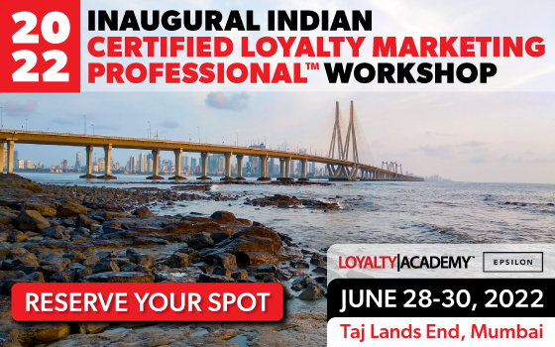

The Loyalty Academy presents
2022 Inaugural India Certification Workshop
Tuesday 28 June to Thursday 30 June, 2022

A professional marketing education program leading to the distinction of being named a Certified Loyalty Marketing Professional™ (CLMP).

Workshop Location and Facilitators
Venue: Taj Lands End, Mumbai.
Address: Band Stand, BJ Road, Mount Mary, Bandra West, Mumbai, Maharashtra 400050

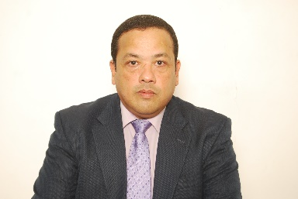

Bill Hanifin, CLMP Mala Raj, CLMP Brian Almeida, CLMP
CEO, The Wise Marketer Group Managing Partners, Strategic Caravan International Pvt Ltd.
Registration Rates:

Rate: $1,000 USD

Special rates available from our partners and sponsors plus Group rates are available for companies who register three or more individuals.

Workshop Overview

The Workshop is an interactive, 3-day training program designed to provide an in-depth assessment of the strategic principles and best practices which govern loyalty marketing programs. The workshop will deliver this assessment from the perspective of both Consumer and B2B customer relationships.

Through a combination of lecture, discussion, case studies and the use of specific loyalty and retention evaluation tools, this workshop seeks to expand the participant’s knowledge and understanding of the available techniques used around the world by loyalty and relationship marketing professionals. The workshop is intended for senior level marketing and loyalty program decision-makers in both Consumer and B2B markets, including those agencies and service providers who support client loyalty programs.

Upon conclusion of the workshop and successful completion of the requirements associated with the Case Study analysis, each participant will earn the distinction as a Certified Loyalty Marketing Professional™ (CLMP)!

Sponsors

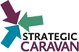

Program Schedule (Days 1 - 3)

8:30 Registration
9:00 Morning session
10:40 – 11:00 Break
12:30 Lunch break
1:30 Afternoon session
3:30 – 3:50 Break
5:00 Session concludes

Full three-day session including lunch each day plus a reception after the first day session. Registration also includes all lecture materials and bonus files with loyalty program design tools.

All attendees are invited to an on-site cocktail party with free beer & wine and snacks hosted by our sponsors. Good networking opportunity!

Detailed Agenda Items (Subject to update)

Strategic Foundations

Principles of Loyalty Marketing
- Overview
- Developing customer relationships
- Is loyalty right for me? For my customers? Why?
- Strong components of a Loyalty Program
- Strategic pillars of Loyalty Marketing
- Loyalty programs today
- Program and financial objectives
- Exercise - Introduction to case study

The Indian Loyalty Landscape
- Consumer perspectives
- B2B issues
- Program Examples

Fundamental Design Principles
- Fundamentals
- Hard and soft benefits and the psychology of rewards
- Segmentation of the customer base & bonusing
- Alternative funding
- Member dialog and engagement
- Measure results and evolve or exit

Best Practices in Program Design
- Behavioral objectives, models, and value propositions and customer segmentation
- Reward spectrum and flexible funding rates
- Dialog and engagement strategies
- Member care and trends
- Exercise – Design considerations for the case study

Turning Strategy into Action

Principles of Communications
- Marketing versus Loyalty communication
- Communication Foundations
- Dialog and listening
- Branding, tactics, tips and examples
- Exercise – communications plan for the case study

Analytical Foundations
- Data sources and measuring key metrics
- Gathering member, transactions and operational information
- Why customer data often aligns with loyalty readiness
- Measurement plans, testing methods and program refreshment
- Competitive intelligence, loyalty scans and reporting
- Value, attrition and potential modeling
- Practical techniques for segmentation
- Exercise – Data definitions from the case study

Operational and Technical Issues
- Does my strategy drive operations and technology?
- Implementation considerations
- Operational considerations
- Technical requirements and alternatives
- Effective use of Technology for members and administrators
- Social and Mobile Landscape
- How to evaluate “total cost of ownership”
- Loyalty platform options
- Exercise – How would you run the case study program?

Rewards Strategies
- Consumer perception and behaviors
- The concept of earning velocity
- Recognition vs. reward
- Reward considerations
- Exercise – Design the rewards catalog for the case study using evaluation tools

Practical Tools and Tips

Financial Planning and Return on Investment
- The finance of loyalty marketing (modelling, forecasting, liability etc.)
- Lift vs. retention – benchmarks for analysis
- Financial analysis before design – A how to approach using case study materials
- ROI Modeling – A how to approach using case study materials and tools

Case Study and Final Examination

- Selected participants will be called upon to discuss a specific aspect to their approach to the case. The workshop facilitators from the Loyalty Academy Faculty will evaluate the participant’s approach. Be prepared!
- The instructors will then reveal what really happened
- Each participant can compare their strategic design to the actual outcome
- Each participant will be given a written examination highlighting all workshop content. You must achieve a passing grade on this exam to be certified!
- A photo ceremony will conclude the workshop!

About the Case Study

A case study of a real-world loyalty design problem is given to all registered participants prior to the start of the workshop. Advance review is requested. Throughout each instructional module of the workshop, participants are asked to discuss and outline their design and strategies for the section being covered. By the end of Day 3, participants will have a high-level design outline for the complete program to compare to the real-world outcome deployed by the client!

BONUS

Each participant will receive three practical tools used during the session, which can be used to assist in the design of a loyalty program. Included are tools for:
- ROI modeling
- Benefit ideation and evaluation
- Evaluating loyalty competence
- Access to the B2B Loyalty Guide

Certification

The Loyalty Academy offers a full professional education program for marketers that culminates in the distinction of becoming a Certified Loyalty Marketing Professional™ (CLMP) upon successful completion of the requirements. Certification bestows upon the recipient the right to use the letters CLMP next to the individual’s name, the recipient inclusion in the online alumni directory, and a diploma suitable for framing. All CLMPs are automatically made members for life in the Loyalty Academy with full complimentary access to all current and future course content plus the digital library housed in the Loyalty Academy Vault.

Benefits of Attendance

Capitalize on the expertise of renowned authorities in the field of loyalty marketing to gain an in-depth understanding of these vital issues:
- Evaluate: if loyalty marketing is the right thing for you and your customers
- Compare: the structural models and strategic designs prevalent in the loyalty industry to determine which approach is best for you and why
- Learn: the practical and proven approaches to customer segmentation that drive best practices in loyalty design
- Understand: the relevant factors which help assess the strengths and weaknesses of loyalty service providers and your internal marketing support
- Align: the operational, technical, communications and rewards components required in all loyalty programs with the strategic and analytical foundation of the program design
- Develop: a suite of best practices and associated tools to help you sort through the many choices you must consider building a new program or enhance an existing program.
- Master: the skills required to expertly model the probable financial return on investment associated with any loyalty initiative
- Uncover: the future trends, which will impact the loyalty industry in the years ahead.
- Begin the path towards professional certification

For additional information contact mikec@loyaltyacademy.org or call +1 844-426-4346.

Or for local contact balmeida@strategiccaravan.com or mala@strategiccaravan.com

See you in Mumbai!

